Setting up Application Environment Create Send Grid Account

|  |  |
| --- | --- |
| Date | 11 November 2022 |
| Team ID | PNT2022TMID34253 |
| Project Name | Skill and Job Recommended |
| Maximum Marks | 2 marks |

Step 1: Navigate to [https://sendgrid.com](https://sendgrid.com/)

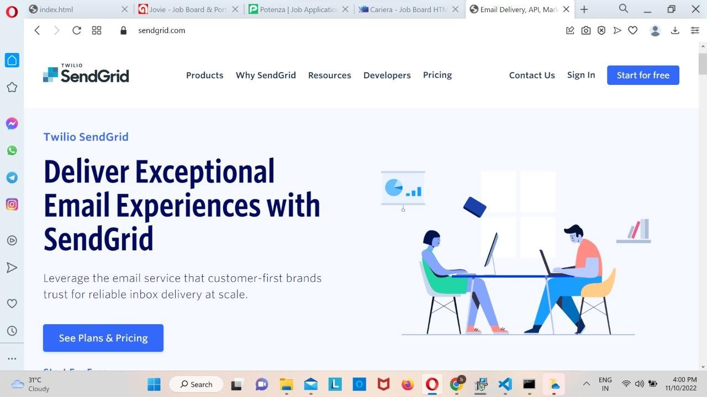

Step 2: Click on “Start for free “and register yourselves by entering required details and click on

create account

Step 3: Further fill all required details in next page and client on get started as shown below

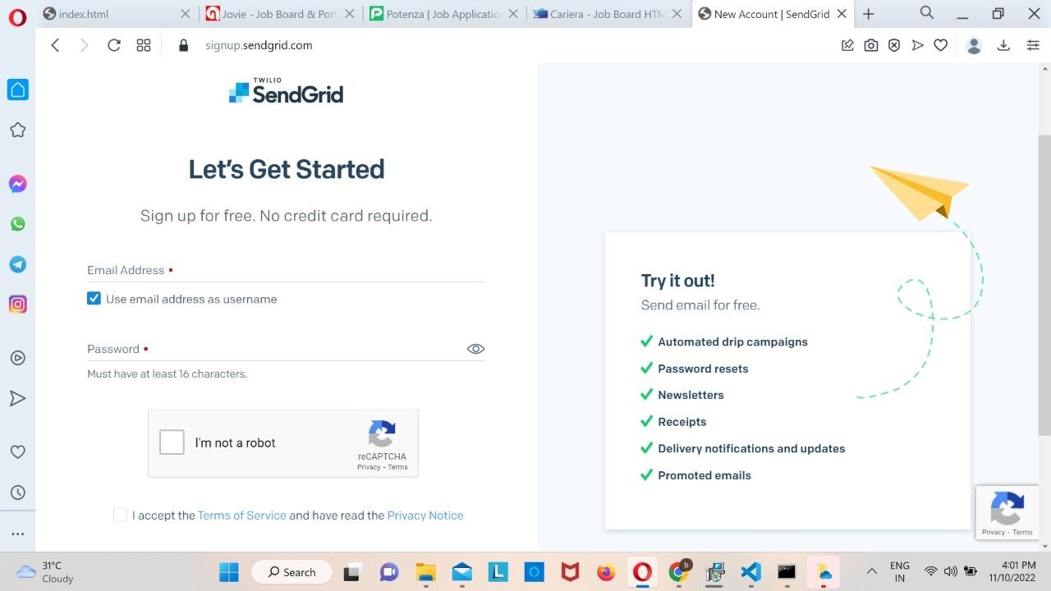

Step 4: That is it you have created your SendGrid account and got access to dashboard

Output: Send Grid account created successfully

